Sanner’s Lake Woodstock Match Report – July 2023

The afternoon started ominously with gathering storm clouds and random raindrops but quickly brightened up with blue sky and bright sun; either way the heat plus humidity remained constant for the nine shooters who filled up the benches at the July Woodstock match at Sanner’s Lake. And when the smoke cleared, it was Ron Ferguson and his FN FAL dancing all around the X-ring and proving that consistency pays off in the long run, taking the top score in the combined category with an excellent 272-0X. In the individual category, Andrey Hetmansky and his M1A showed that one good string is all it takes to nab the top single high score with a strong 95-1X. See all the scores and details below. The next Woodstock match is on August 17th; grab your vintage rifle and, in the words of the late great Jim Scoutten: “shoot safely, shoot often, and keep ‘em in the ten ring!”.

Combined Scores:
SR-21 Target 100 yards
Place | Name | Rifle | String 1 | X | String 2 | X | String 3 | X | Total | X
1 | Ron Ferguson | FN FAL | 92 | 0 | 92 | 0 | 88 | 0 | 272 | 0
2 | Mark Swierczek | BM 59 | 86 | 0 | 88 | 2 | 93 | 2 | 267 | 4
3 | Alex Chung | Swedish M96 | 83 | 0 | 85 | 0 | 86 | 0 | 254 | 0
4 | Andrey Hetmansky | Springfield M1A | 74 | 0 | 95 | 1 | 84 | 0 | 253 | 1
5 | Jeremy Hanson | K98k Mauser | 82 | 0 | 85 | 1 | 77 | 1 | 244 | 2
6 | Paul Stephens | Sharps 1874 | 81 | 0 | 84 | 0 | 79 | 0 | 244 | 0
7 | Bill Franceschini | Mosin Nagant | 74 | 0 | 78 | 0 | 73 | 0 | 225 | 0
8 | Rick Mongello | Type 56 SKS | 12 | 0 | 75 | 0 | 52 | 0 | 139 | 0
9 | Jeff Heisler | Egyptian Hakim Rifle | Withdrew, disabled rifle
300 total points possible. Ties broken by X's and then by highest individual string.

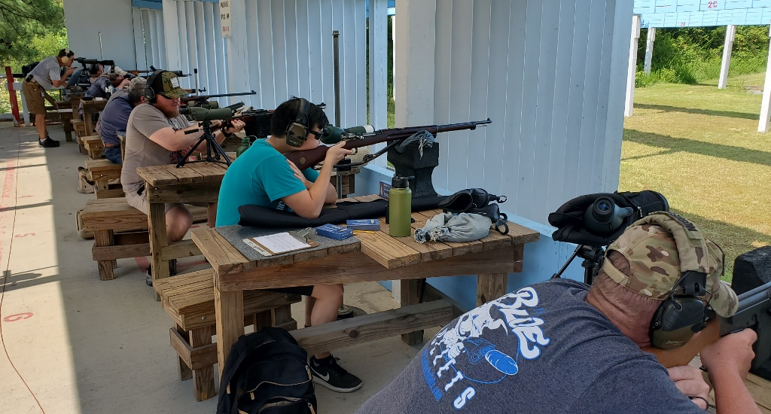

Individual Scores:

SR-21 Target 100 yards
Place | Name | Rifle | Caliber | Score | X
1 | Andrey Hetmansky | Springfield M1A | .308 Winchester | 95 | 1
2 | Mark Swierczek | BM 59 | 7.62×51mm NATO | 93 | 2
3 | Ron Ferguson | FN FAL | 7.62×51mm NATO | 92 | 0
4 | Ron Ferguson | FN FAL | 7.62×51mm NATO | 92 | 0
5 | Mark Swierczek | BM 59 | 7.62×51mm NATO | 88 | 2
6 | Ron Ferguson | FN FAL | 7.62×51mm NATO | 88 | 0
7 | Mark Swierczek | BM 59 | 7.62×51mm NATO | 86 | 0
8 | Alex Chung | Swedish M96 | 6.5×55 Swedish | 86 | 0
9 | Jeremy Hanson | K98k Mauser | 8mm Mauser | 85 | 1
10 | Alex Chung | Swedish M96 | 6.5×55 Swedish | 85 | 0
11 | Paul Stephens | Sharps 1874 | .45-70 Government | 84 | 0
12 | Andrey Hetmansky | Springfield M1A | .308 Winchester | 84 | 0
13 | Alex Chung | Swedish M96 | 6.5×55 Swedish | 83 | 0
14 | Jeremy Hanson | K98k Mauser | 8mm Mauser | 82 | 0
15 | Paul Stephens | Sharps 1874 | .45-70 Government | 81 | 0
16 | Paul Stephens | Sharps 1874 | .45-70 Government | 79 | 0
17 | Bill Franceschini | Mosin Nagant | 7.62x54mmR | 78 | 0
18 | Jeremy Hanson | K98k Mauser | 8mm Mauser | 77 | 1
19 | Rick Mongello | Type 56 SKS | 7.62×39mm | 75 | 0
20 | Andrey Hetmansky | Springfield M1A | .308 Winchester | 74 | 0
21 | Bill Franceschini | Mosin Nagant | 7.62x54mmR | 74 | 0
22 | Bill Franceschini | Mosin Nagant | 7.62x54mmR | 73 | 0
23 | Rick Mongello | Type 56 SKS | 7.62×39mm | 52 | 0
24 | Rick Mongello | Type 56 SKS | 7.62×39mm | 12 | 0
100 points possible. Ties broken by X's and then by fewest hits of lowest value.
