Sanner’s Lake Woodstock Match Report – October 2021

A crowded contingent of classic military rifle shooters took advantage of the gorgeous autumn weather making for a full firing line at the October Woodstock match at Sanner’s Lake...a fitting way to end the season! Jonathan Ramsey battled the late afternoon sun glinting off the sights of his Schmidt-Rubin but shook it off and managed to take the top combined score with an excellent 283-8X. Right behind him Ron Ferguson kept the race tight with his Polytech M14, even engaging in some field expedient repairs right in the middle of a string (and losing his zero momentarily!) but he still put together an impressive 276-4X to take second place combined. And proving that an M1 Carbine can hold its own with the big guns, Ed Thompson and his Inland racked up a superb series of scores to take third place with an awesome 269-3X combined, an M1 Carbine Woodstock match record! See all the scores and details below.

That’s a wrap for Woodstock matches at Sanner’s Lake for 2021...thanks to everyone for supporting the program and keeping the old warhorses on the line and slinging lead. We’ll kick things off next year with the annual Frozen Chosin match in the Jan/Feb 2022 timeframe...keep an eye on the club website for specifics as they become available. See you there!

Combined Scores:

SR-21 Target 100 yards
Place | Name | Rifle | String1 | X | String2 | X | String3 | X | Total | X
1 | Jonathan Ramsey | Schmidt–Rubin 1911 | 94 | 3 | 94 | 1 | 95 | 4 | 283 | 8
2 | Ron Ferguson | Polytech M14 | 93 | 1 | 93 | 1 | 90 | 2 | 276 | 4
3 | Ed Thompson | Inland M1 Carbine | 92 | 2 | 92 | 1 | 85 | 0 | 269 | 3
4 | Mike DiZebba | Springfield M1 Garand | 81 | 2 | 91 | 1 | 91 | 0 | 263 | 3
5 | Asher Maroot | Inland M1 Carbine | 73 | 1 | 74 | 1 | 84 | 0 | 231 | 2
6 | Greg Banta | M1 Garand | 66 | 1 | 76 | 0 | 79 | 0 | 221 | 1
7 | Paul Stephens | Enfield No. 1 Mk III | 57 | 0 | 72 | 0 | 32 | 0 | 161 | 0
8 | Vicente Montes Cintron | Mosin–Nagant M39 | 58 | 0 | 44 | 0 | 42 | 0 | 144 | 0
300 total points possible. Ties broken by X's and then by highest individual string.

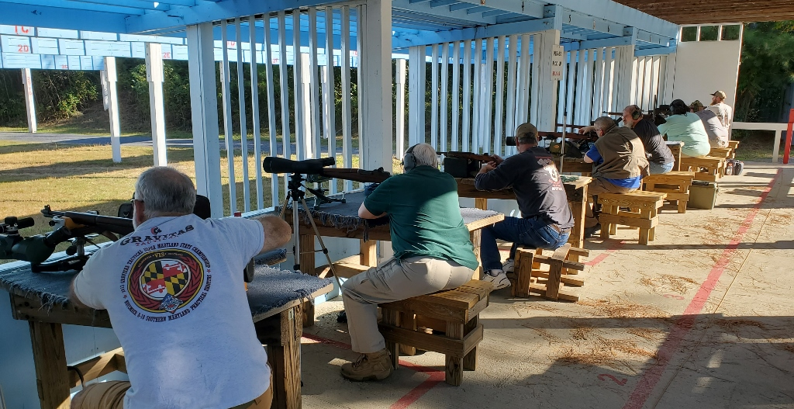
Individual Scores:
SR-21 Target 100 yards
Place | Name | Rifle | Caliber | Score | X
1 | Jonathan Ramsey | Schmidt–Rubin 1911 | 7.5×55mm Swiss | 95 | 4
2 | Jonathan Ramsey | Schmidt–Rubin 1911 | 7.5×55mm Swiss | 94 | 3
3 | Jonathan Ramsey | Schmidt–Rubin 1911 | 7.5×55mm Swiss | 94 | 1
4 | Ron Ferguson | Polytech M14 | 7.62×51mm NATO | 93 | 1
5 | Ron Ferguson | Polytech M14 | 7.62×51mm NATO | 93 | 1
6 | Ed Thompson | Inland M1 Carbine | .30 Carbine | 92 | 2
7 | Ed Thompson | Inland M1 Carbine | .30 Carbine | 92 | 1
8 | Mike DiZebba | Springfield M1 Garand | .308 Winchester | 91 | 1
9 | Mike DiZebba | Springfield M1 Garand | .308 Winchester | 91 | 0
10 | Ron Ferguson | Polytech M14 | 7.62×51mm NATO | 90 | 2
11 | Ed Thompson | Inland M1 Carbine | .30 Carbine | 85 | 0
12 | Asher Maroot | Inland M1 Carbine | .30 Carbine | 84 | 0
13 | Mike DiZebba | Springfield M1 Garand | .308 Winchester | 81 | 2
14 | Greg Banta | M1 Garand | .30-06 Springfield | 79 | 0
15 | Greg Banta | M1 Garand | .30-06 Springfield | 76 | 0
16 | Asher Maroot | Inland M1 Carbine | .30 Carbine | 74 | 1
17 | Asher Maroot | Inland M1 Carbine | .30 Carbine | 73 | 1
18 | Paul Stephens | Enfield No. 1 Mk III | .303 British | 72 | 0
19 | Greg Banta | M1 Garand | .30-06 Springfield | 66 | 1
20 | Vicente Montes Cintron | Mosin–Nagant M39 | 7.62x54mmR | 58 | 0
21 | Paul Stephens | Enfield No. 1 Mk III | .303 British | 57 | 0
22 | Vicente Montes Cintron | Mosin–Nagant M39 | 7.62x54mmR | 44 | 0
23 | Vicente Montes Cintron | Mosin–Nagant M39 | 7.62x54mmR | 42 | 0
24 | Paul Stephens | Enfield No. 1 Mk III | .303 British | 32 | 0
100 points possible. Ties broken by X's and then by fewest hits of lowest value.

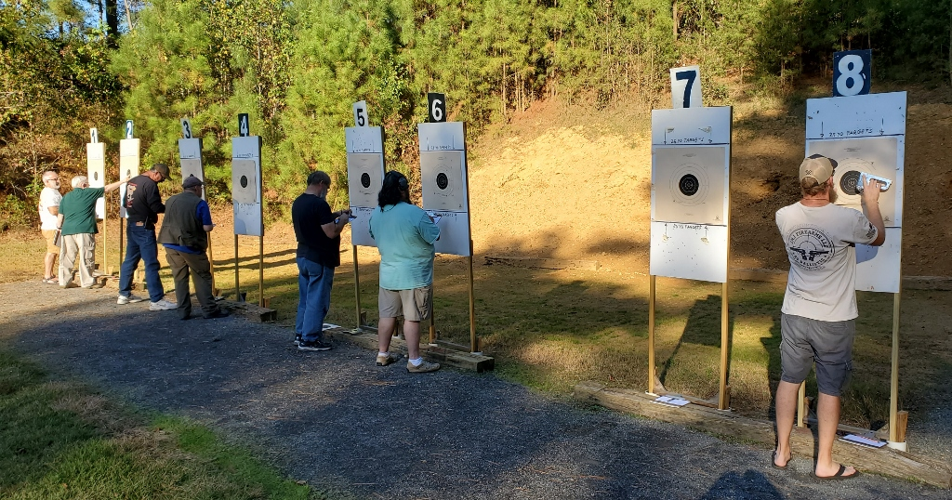

Fantastic Group for an M1 Carbine (ignore that pesky flyer)!

