Sanner’s Lake Woodstock Match Report – July 2018

The weather was warm and comfortably dry which no doubt contributed to the healthy turnout and strong competition at the July Woodstock Match at Sanner’s Lake! The top four spots in the combined score category were all within a point of each other with Ron Ferguson and his Garand grabbing the win with a stout 275-6X. Dick Chadwick was right behind him taking runner-up with a 274-3X and Mark Swierczek was right behind him taking third with a 273-1X and Jake Swierczek was right behind him with a 272-2X! The competition was similarly tight in the individual score category with Ron taking the win once again with an excellent 94-3X, beating Mark’s 94-0X by virtue of his higher X-count. And in keeping with the July theme of tight competition, the tie-breaking rules were insufficient to separate the high individual scores of Dick Chadwick and Jake Swierczek so they shared third place in the individual score category with identical 93-1X scoresheets.

Thanks to everyone for dragging their old shooting irons out to the range and letting them strut their stuff, keeping the scores high and the fun factor higher! The next match will be on August 16th, see you then...

Combined Scores:
SR-21 Target 100 yards
Place | Name | Rifle | String1 | X | String2 | X | String3 | X | Total | X
1 | Ron Ferguson | M1 Garand | 92 | 1 | 89 | 2 | 94 | 3 | 275 | 6
2 | Dick Chadwick | Springfield M1903A3 | 93 | 1 | 91 | 2 | 90 | 0 | 274 | 3
3 | Mark Swierczek | Springfield M1903 Mark I | 89 | 0 | 90 | 1 | 94 | 0 | 273 | 1
4 | Jake Swierczek | BM 59 | 87 | 0 | 93 | 1 | 92 | 1 | 272 | 2
5 | David Zeigler | Springfield M1 Garand | 86 | 0 | 85 | 0 | 86 | 0 | 257 | 0
6 | Terry Wanner | M1 Garand | 86 | 1 | 81 | 1 | 89 | 2 | 256 | 4
7 | Jesse Williams | Finnish M39 | 84 | 0 | 80 | 1 | 89 | 1 | 253 | 2
8 | Joe Maida | Springfield M1 Garand | 77 | 0 | 85 | 0 | 84 | 0 | 246 | 0
9 | Trevor Graves | Swiss K31 | 79 | 0 | 84 | 1 | 81 | 1 | 244 | 2
10 | John Graves | M1 Garand | 81 | 0 | 75 | 0 | 87 | 1 | 243 | 1
11 | Tom Vandenberg | M1 Garand | 75 | 0 | 71 | 0 | 83 | 1 | 229 | 1
Note: 300 total points possible. Ties broken by X's and then by highest individual string.

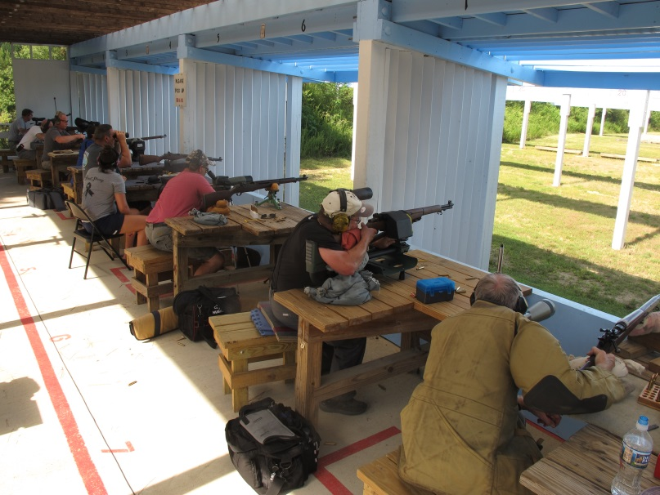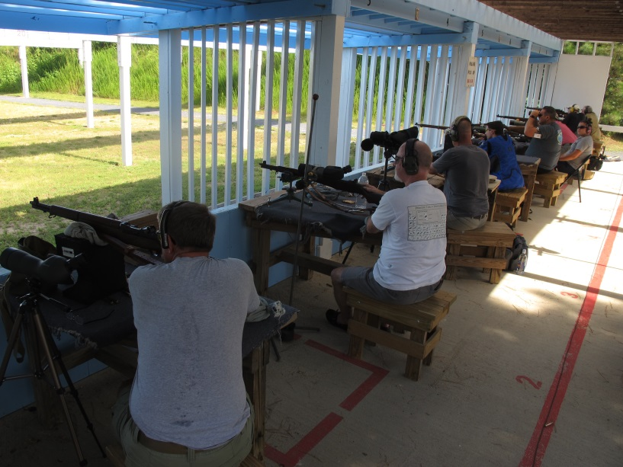

Individual Scores:
SR-21 Target 100 yards
Place | Name | Rifle | Caliber | Score | X
1 | Ron Ferguson | M1 Garand | .30-06 Springfield | 94 | 3
2 | Mark Swierczek | Springfield M1903 Mark I | .30-06 Springfield | 94 | 0
3 (tie) | Dick Chadwick | Springfield M1903A3 | .30-06 Springfield | 93 | 1
 | Jake Swierczek | BM 59 | 7.62×51mm NATO | 93 | 1
5 | Ron Ferguson | M1 Garand | .30-06 Springfield | 92 | 1
6 | Jake Swierczek | BM 59 | 7.62×51mm NATO | 92 | 1
7 | Dick Chadwick | Springfield M1903A3 | .30-06 Springfield | 91 | 2
8 | Mark Swierczek | Springfield M1903 Mark I | .30-06 Springfield | 90 | 1
9 | Dick Chadwick | Springfield M1903A3 | .30-06 Springfield | 90 | 0
10 | Ron Ferguson | M1 Garand | .30-06 Springfield | 89 | 2
11 | Terry Wanner | M1 Garand | .30-06 Springfield | 89 | 2
12 | Jesse Williams | Finnish M39 | 7.62x54mmR | 89 | 1
13 | Mark Swierczek | Springfield M1903 Mark I | .30-06 Springfield | 89 | 0
14 | John Graves | M1 Garand | .30-06 Springfield | 87 | 1
15 | Jake Swierczek | BM 59 | 7.62×51mm NATO | 87 | 0
16 | Terry Wanner | M1 Garand | .30-06 Springfield | 86 | 1
17 | David Zeigler | Springfield M1 Garand | .30-06 Springfield | 86 | 0
18 | David Zeigler | Springfield M1 Garand | .30-06 Springfield | 86 | 0
19 | David Zeigler | Springfield M1 Garand | .30-06 Springfield | 85 | 0
20 | Joe Maida | Springfield M1 Garand | .30-06 Springfield | 85 | 0
21 | Trevor Graves | Swiss K31 | 7.5×55mm Swiss | 84 | 1
22 | Jesse Williams | Finnish M39 | 7.62x54mmR | 84 | 0
23 | Joe Maida | Springfield M1 Garand | .30-06 Springfield | 84 | 0
24 | Tom Vandenberg | M1 Garand | .30-06 Springfield | 83 | 1
25 | Terry Wanner | M1 Garand | .30-06 Springfield | 81 | 1
26 | Trevor Graves | Swiss K31 | 7.5×55mm Swiss | 81 | 1
27 | John Graves | M1 Garand | .30-06 Springfield | 81 | 0
28 | Jesse Williams | Finnish M39 | 7.62x54mmR | 80 | 1
29 | Trevor Graves | Swiss K31 | 7.5×55mm Swiss | 79 | 0
30 | Joe Maida | Springfield M1 Garand | .30-06 Springfield | 77 | 0
31 | Tom Vandenberg | M1 Garand | .30-06 Springfield | 75 | 0
32 | John Graves | M1 Garand | .30-06 Springfield | 75 | 0
33 | Tom Vandenberg | M1 Garand | .30-06 Springfield | 71 | 0
Note: 100 points possible. Ties broken by X's and then by fewest hits of lowest value.

