It was a classic mid-November day at the range, with beautiful autumn colors and crisp but not cold breezes, which led to another packed relay of shooters at the November Rimfire Sporter match at Sanner’s Lake! As usual, there was an interesting assortment of rimfire rifles on the line, including a classic Winchester 52 with vintage scope, as well as a rare Gevarm A6 with its unusual firing-from-an-open-bolt operation. The race for first place was pretty close all day, but when the smoke finally cleared, it was new rimfire sporter shooter Joe Mund and his Anschutz 1422 at the top of the heap with an excellent 572-18X. Right behind him, Jake Swierczek shrugged off the clunky firing action and rudimentary iron sights of the Gevarm and wrung a 560-5X out of it, good enough to take second place. Rounding out the top three, James Butchko III put his Mossberg Plinkster to good use with a solid 531-2X nabbing third place. See all the scores and details below.
Thanks to everyone for supporting the program this year, there’s nothing like a full firing line to close out the year on a good note! Keep an eye on the Sanner’s Club calendar for next year’s schedule of matches. See you then!

CMP B-19 Target 50/25yards
Place | Name | Rifle | Sights | Prone  Slow | X | Prone  Rapid | X | Sitting  Slow | X | Sitting  Rapid | X | Standing  Slow | X | Standing  Rapid | X | Total | X
1 | Joe Mund | Anschutz 1422 | Scope | 96 | 3 | 92 | 1 | 98 | 4 | 98 | 4 | 95 | 3 | 93 | 3 | 572 | 18
2 | Jake Swierczek | Gevarm A6 | Irons | 92 | 1 | 94 | 2 | 92 | 0 | 93 | 1 | 95 | 0 | 94 | 1 | 560 | 5
3 | James Butchko III | Mossberg 715T Plinkster | Scope | 90 | 1 | 90 | 0 | 85 | 0 | 84 | 0 | 95 | 1 | 87 | 0 | 531 | 2
4 | Greg Banta | Nordic 22 AR | Dot | 93 | 1 | 92 | 2 | 92 | 1 | 89 | 2 | 79 | 0 | 84 | 2 | 529 | 8
5 | Pat Farrar | Ruger 10/22 | Scope | 95 | 2 | 95 | 2 | 83 | 2 | 73 | 1 | 89 | 1 | 89 | 1 | 524 | 9
6 | James Black | Ruger 10/22 | Scope | 90 | 1 | 92 | 2 | 88 | 1 | 80 | 1 | 90 | 2 | 84 | 0 | 524 | 7
7 | James Butchko Jr. | Winchester Model 52 | Scope | 89 | 3 | 94 | 4 | 90 | 3 | 70 | 1 | 87 | 0 | 73 | 0 | 503 | 11
8 | Tom Reider | CZ 455 American | Scope | 77 | 0 | 72 | 0 | 73 | 1 | 75 | 0 | 76 | 0 | 76 | 2 | 449 | 3
600 total points possible. Ties broken by X count.

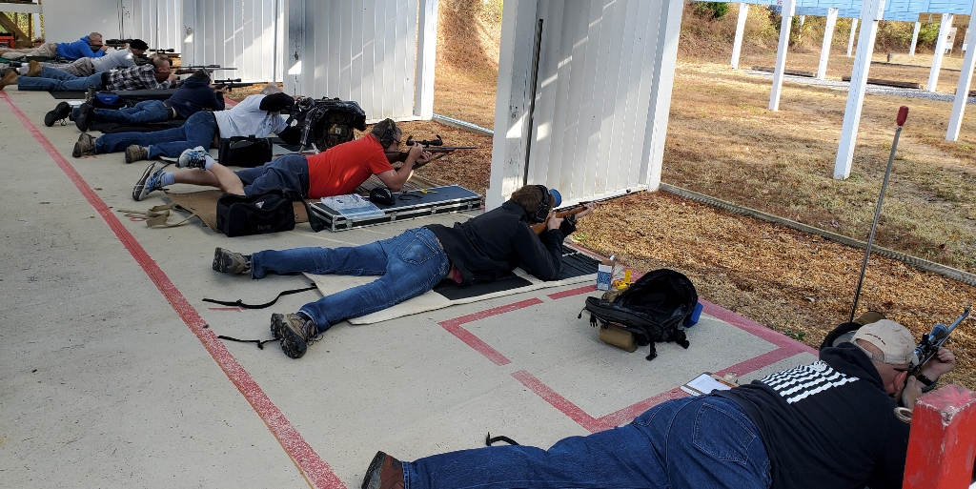

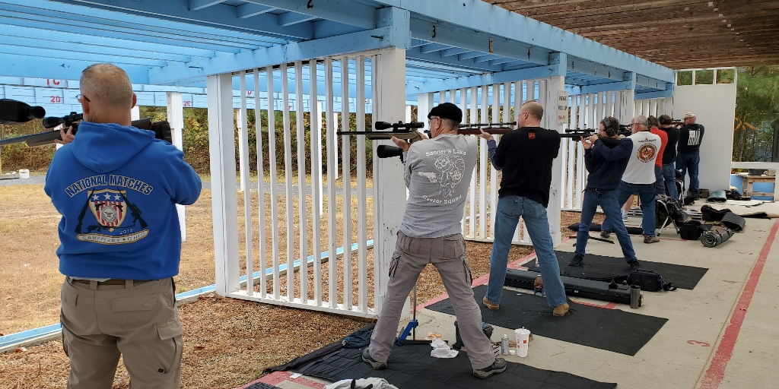

Notes on Rimfire Sporter:
Stage 1 = prone slow fire, 10 shots in 10 minutes, CMP B-19 target at 50 yards
Stage 2 = prone rapid fire, two strings of 5 shots in 30 seconds, CMP B-19 target at 50 yards
Stage 3 = sitting or kneeling slow fire, 10 shots in 10 minutes, CMP B-19 target at 50 yards
Stage 4 = sitting or kneeling rapid fire, two strings of 5 shots in 30 seconds, CMP B-19 target at 50 yards
Stage 5 = standing slow fire, 10 shots in 10 minutes, CMP B-19 target at 25 yards
Stage 6 = standing rapid fire, two strings of 5 shots in 30 seconds, CMP B-19 target at 25 yards

