Sanner’s Lake IR5050 Rimfire Benchrest Match Report
1 October 2023

A beautiful fall afternoon greeted competitors at the October IR5050-style rimfire benchrest match at Sanner’s Lake, the final such match of the year, and the scores were excellent in spite of the occasional breeziness. Dave Heilmeier saw his score ratchet up on each string, keeping the pressure on throughout the match and notching a few personal bests along the way. Likewise Jeff Heisler recovered from his scope issues at the previous match and laid down some solid scores across the board. Expect both of them to be in contention for the top spots when the rimfire benchrest matches resume next year! See all the scores, pictures, and other details below.

Keep your eye on the Sanner’s Lake calendar for next year’s rimfire rifle match schedule and we’ll see you in the spring...

Individual Scores:

Place | Name | Rifle | Score | X
1 | Mark Swierczek | Anschutz 54 MS | 248 | 12
2 | Mark Swierczek | Anschutz 54 MS | 242 | 8
3 | Dave Heilmeier | Anschutz 1903 M64 | 241 | 12
4 | Mark Swierczek | Anschutz 54 MS | 241 | 6
5 | Dave Heilmeier | Anschutz 1903 M64 | 239 | 6
6 | Jeff Heisler | Savage MkII | 225 | 3
7 | Dave Heilmeier | Anschutz 1903 M64 | 220 | 1
8 | Jeff Heisler | Savage MkII | 218 | 0
9 | Jeff Heisler | Savage MkII | 215 | 1
10 | Fran Cox | Ruger 10/22 | 192 | 2
11 | Fran Cox | Ruger 10/22 | 180 | 1
12 | Fran Cox | Ruger 10/22 | 151 | 1
Note: 250 points possible. Ties broken by X count, then by first target block with highest score

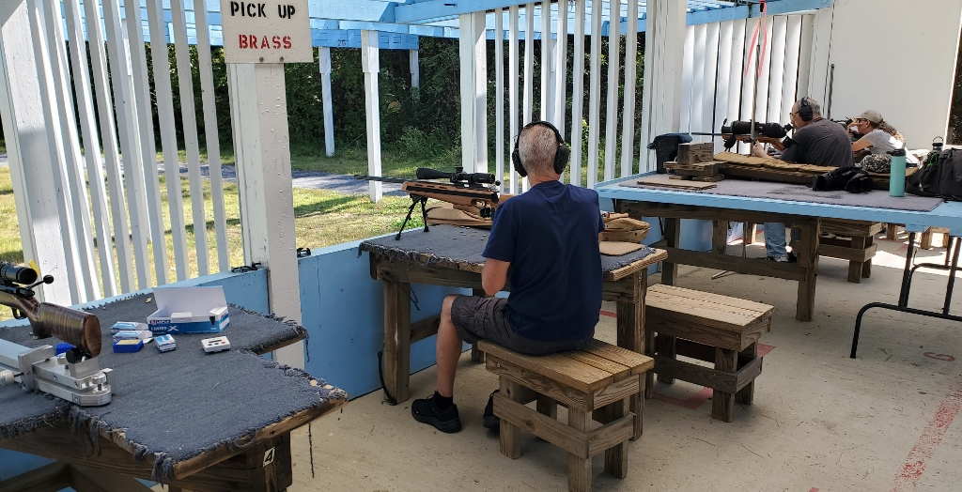

Combined Scores:

Place | Name | Rifle | String 1 | X | String 2 | X | String 3 | X | Total | X
1 | Mark Swierczek | Anschutz 54 MS | 242 | 8 | 241 | 6 | 248 | 12 | 731 | 26
2 | Dave Heilmeier | Anschutz 1903 M64 | 220 | 1 | 239 | 6 | 241 | 12 | 700 | 19
3 | Jeff Heisler | Savage MkII | 218 | 0 | 215 | 1 | 225 | 3 | 658 | 4
4 | Fran Cox | Ruger 10/22 | 192 | 2 | 151 | 1 | 180 | 1 | 523 | 4
Note: 750 total points possible. Ties broken by X count.
