Sanner’s Lake Frozen Chosin Match Report
02/13/21

A national weather service weather warning and potential ice storm didn’t stop an intrepid band of shooters from attending the sixth annual Frozen Chosin match at Sanner’s Lake! Freezing rain and overall dreary conditions made for an appropriate backdrop to remember the service of those Americans who endured the hardships of the Korean War while ensuring their sacrifice will not be forgotten.

It was an all-American line-up on the firing line this year, with nothing but M1 Garands and M1 Carbines filling out the shooting stations from end to end. In fact, the Carbines actually outnumbered the Garands this year, which was great to see and highly appropriate for this match.

And when the smoke finally cleared, it was Ed Thompson and his M1 Carbine holding off the Garands and taking the overall victory over with an excellent 264-4X. Never let it be said that an M1 Carbine can’t hold its own at 100 yards! Breathing down his neck, though, was Larry Chiarizia and his Garand keeping it close with a superb 262-4X. Filling out the podium was the M1 Carbine of Jake Swierczek, who overcame several magazine feeding issues to nab third place with a strong 250-2X.

See all the scores and pictures from the match below.

Thanks to everybody for shrugging off the miserable (but appropriate) conditions and making it out the range to keep the match going with some great shooting and great scores! Keep an eye on the Sanners calendar for future Vintage Military Rifle matches as well as our Woodstock matches which will be starting back up the March timeframe. Hopefully the ice will have melted by then...

SR-1 Target 100 yards
Place | Name | Rifle | Caliber | Prone  Slow | Prone  Rapid | Standing  Slow | TOTAL
1 | Ed Thompson | M1 Carbine | .30 Carbine | 93-2X | 89-2X | 82-0X | 264-4X
2 | Larry Chiarizia | M1 Garand | .30-06 Springfield | 89-2X | 90-2X | 83-0X | 262-4X
3 | Jake Swierczek | M1 Carbine | .30 Carbine | 88-2X | 80-0X | 82-0X | 250-2X
4 | Asher Maroot | M1 Carbine | .30 Carbine | 84-1X | 90-0X | 74-0X | 248-1X
5 | James Black | M1 Garand | .30-06 Springfield | 77-1X | 88-1X | 79-0X | 244-2X
6 | Nathanial Swift | M1 Carbine | .30 Carbine | 73-0X | 68-0X | 72-0X | 213-0X
7 | Donald Cooper | M1 Garand | .30-06 Springfield | 53-0X | 34-0X | 40-0X | 127-0X
Note: 300 total points possible. Ties broken by X's and then by highest individual string.

Blasing snow off the line...

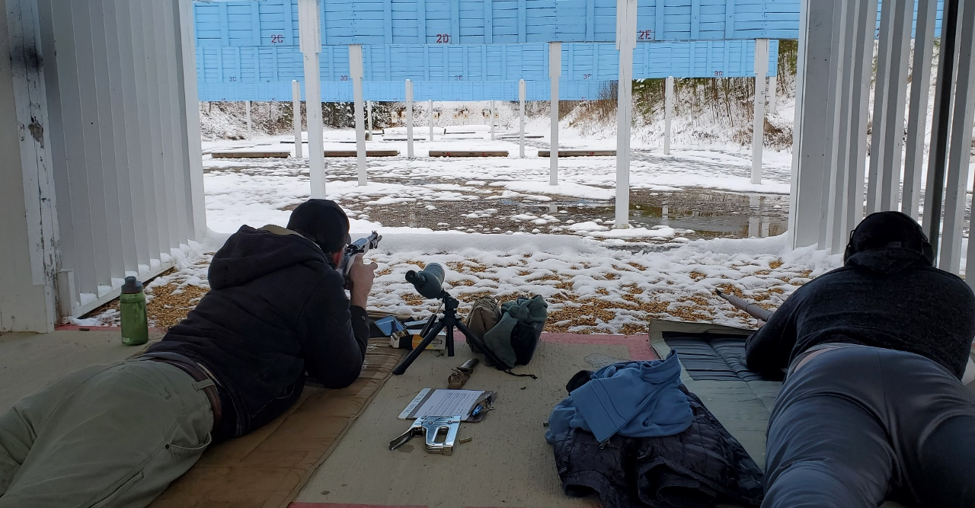

...and the baffles:

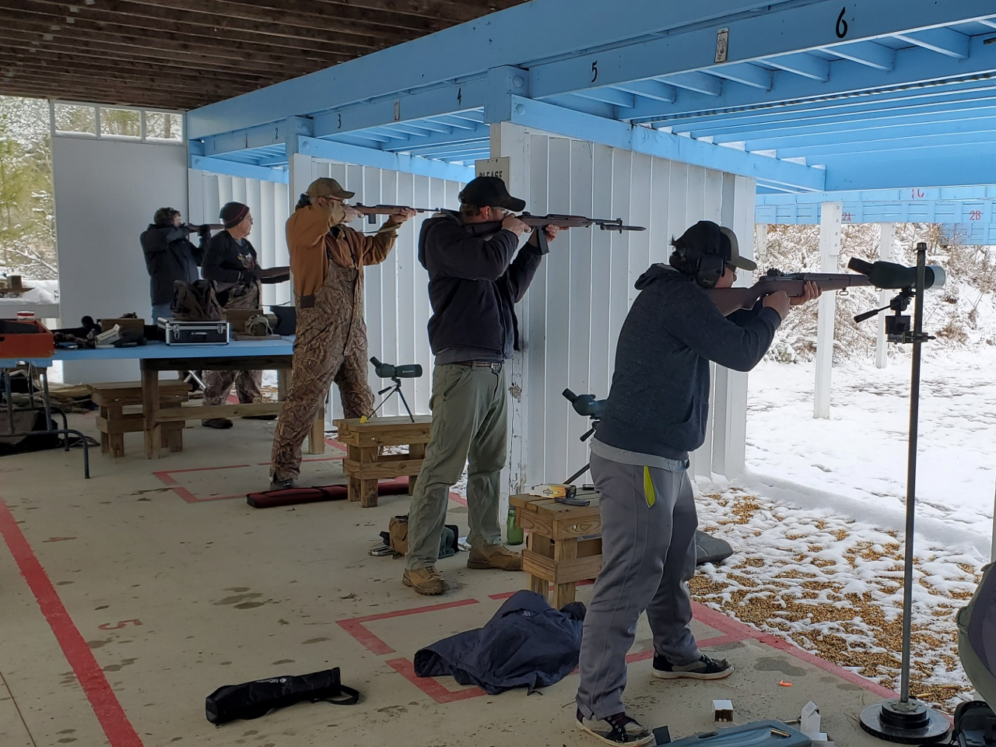

The long slog to the targets...

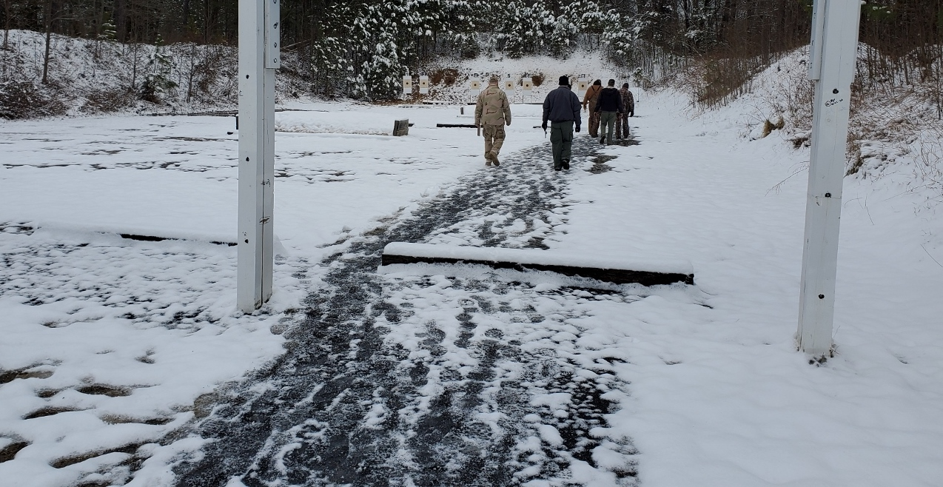

...to score and comiserate:

