Sanner’s Lake Frozen Chosin Match Report
01/27/24

The freezing weather that crept in and clamped its icy tentacles over Southern Maryland for the first few weeks of 2024 was tragically nowhere to be seen as the sun rose over Sanner’s Lake for the ninth annual Frozen Chosin match. But the perfectly pleasant conditions didn’t deter ten competitors who made their way to the SLSC rifle range to do battle against paper targets in remembrance of those who fought and died taking a stand for freedom at the brutal Battle of Chosin Reservoir.

The firing line was dominated by M1 Carbines, rightfully so, with a sprinkling of Garands as well as a lone ’03 Springfield providing an appropriately period-correct representation of Allied firepower. And so, the battle commenced, with fierce fighting from one end of the firing line to the other. As the first relay came to a close Greg Banta found himself sitting comfortably in first place with a strong 244-1X. However he then made a grave tactical error by offering his gun to the match director (who hadn’t planned to shoot) and insisting he shoot the second relay... with Greg even providing the ammo. Well, no good deed goes unpunished, and as the second relay wound down Greg found himself bounced back to second place! But at least he could take solace in the fact that his Carbine (along with his reloaded ammo) worked perfectly. Further down the standings, the Carbines continued to put on a strong showing, holding their own between the Garands and the lone Springfield with just ten points separating the next five scores. See all the scores and details (plus a few pictures) below.

Thanks to everybody for making it to the range and putting their classic battle rifles to the test regardless of the beautiful weather...and, more importantly, helping out fellow competitors regardless of consequences in the spirit of the Chosin Few. As the vernal equinox approaches and we get closer to legitimate springtime weather, be sure to bookmark the Sanner’s club calendar and take note of the rifle matches, vintage and otherwise, that will be starting back up in the March timeframe.

Until then, don’t be a stranger and we’ll see you at the range!

SR-1 Target 100 yards
Place | Name | Rifle | Caliber | Prone  Slow | X | Prone  Rapid | X | Standing  Slow | X | Total | X
1 | Mark Swierczek | M1 Carbine | .30 Carbine | 93 | 1 | 89 | 0 | 85 | 0 | 267 | 1
2 | Greg Banta | M1 Carbine | .30 Carbine | 90 | 1 | 78 | 0 | 76 | 0 | 244 | 1
3 | Nathanial Swift | M1 Garand | .30-06 Springfield | 84 | 0 | 90 | 1 | 64 | 2 | 238 | 3
4 | Ed Thompson | M1 Carbine | .30 Carbine | 81 | 0 | 83 | 0 | 74 | 0 | 238 | 0
5 | Ed Thompson | M1 Carbine | .30 Carbine | 84 | 0 | 76 | 0 | 77 | 0 | 237 | 0
6 | Dave Heilmeyer | M1 Carbine | .30 Carbine | 68 | 0 | 90 | 0 | 75 | 0 | 233 | 0
7 | John Norman | M1903A3 | .30-06 Springfield | 87 | 1 | 77 | 1 | 64 | 0 | 228 | 2
8 | Dave Heilmeyer | M1 Carbine | .30 Carbine | 80 | 0 | 71 | 0 | 76 | 1 | 227 | 1
9 | Pat Patton | M1 Carbine | .30 Carbine | 75 | 0 | 81 | 0 | 57 | 0 | 213 | 0
10 | Jeremy Hanson | M1 Garand | .30-06 Springfield | 68 | 0 | 73 | 0 | 71 | 0 | 212 | 0
11 | Jonathan Ramsey | M1 Carbine | .30 Carbine | 85 | 0 | 80 | 1 | 37 | 0 | 202 | 1
12 | Pat Patton | M1 Carbine | .30 Carbine | 77 | 0 | 69 | 0 | 52 | 0 | 198 | 0
13 | Dave Kelnberger | M1 Garand | .30-06 Springfield | 61 | 0 | 29 | 0 | 53 | 0 | 143 | 0
14 | Dave Kelnberger | M1 Garand | .30-06 Springfield | 37 | 0 | 31 | 0 | 29 | 0 | 97 | 0
300 total points possible. Ties broken by X's and then by highest standing score.

Prone Slow – a chance to nail that perfect group...
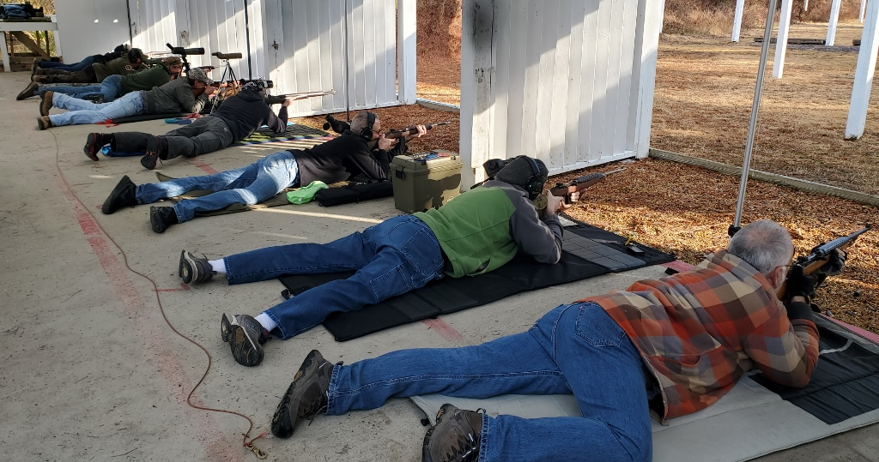

... before things go downhill at the ever-popular Standing Stage:
