Sanner’s Carbine Classic September Match Report
9/11/2021

Perfect weather greeted competitors on the range this morning for the September Sanner’s Carbine Classic. After a moment of silence dedicated to the victims of the September 11th attacks we got to the shooting, and cool air allowed the competition to really heat up!

Stages for this match focused on high levels of movement utilizing the entire shooting bay for each stage. We also had a new stage designer try his hand at the craft, deciding to torture our poor patrons with a tight stage heavy on shoulder-switching and side-to-side movement. Hopefully he has more where that came from.

As always, those in Prepper kept their wits about them as well as their gear, ammo, and rifles. Even on such a nice day the weight and bulk of equipment is no trivial factor and congratulations go out to every Prepper that completed the match. But it was Anibal Delgado finishing strong, taking first in that category and fourth overall!

Included below is the link to the scores posted on Practiscore as well as a couple photos snagged during the match.

https://practiscore.com/results/new/146777

Special recognition must be given to Tim Kelly and James Butchko III as our only Ironman competitors, Harry Bowling as the top Active Duty competitor, Jim Habercam as the high senior, Andrea Swierczek as the high lady, and finally Jordan Bowling as top Junior! Great shooting!

The next match will be October 30th, sign up information will be provided separately so stay tuned to the Sanner’s website for the status of upcoming matches.

-Jake Swierczek

Sometimes it helps to be left handed

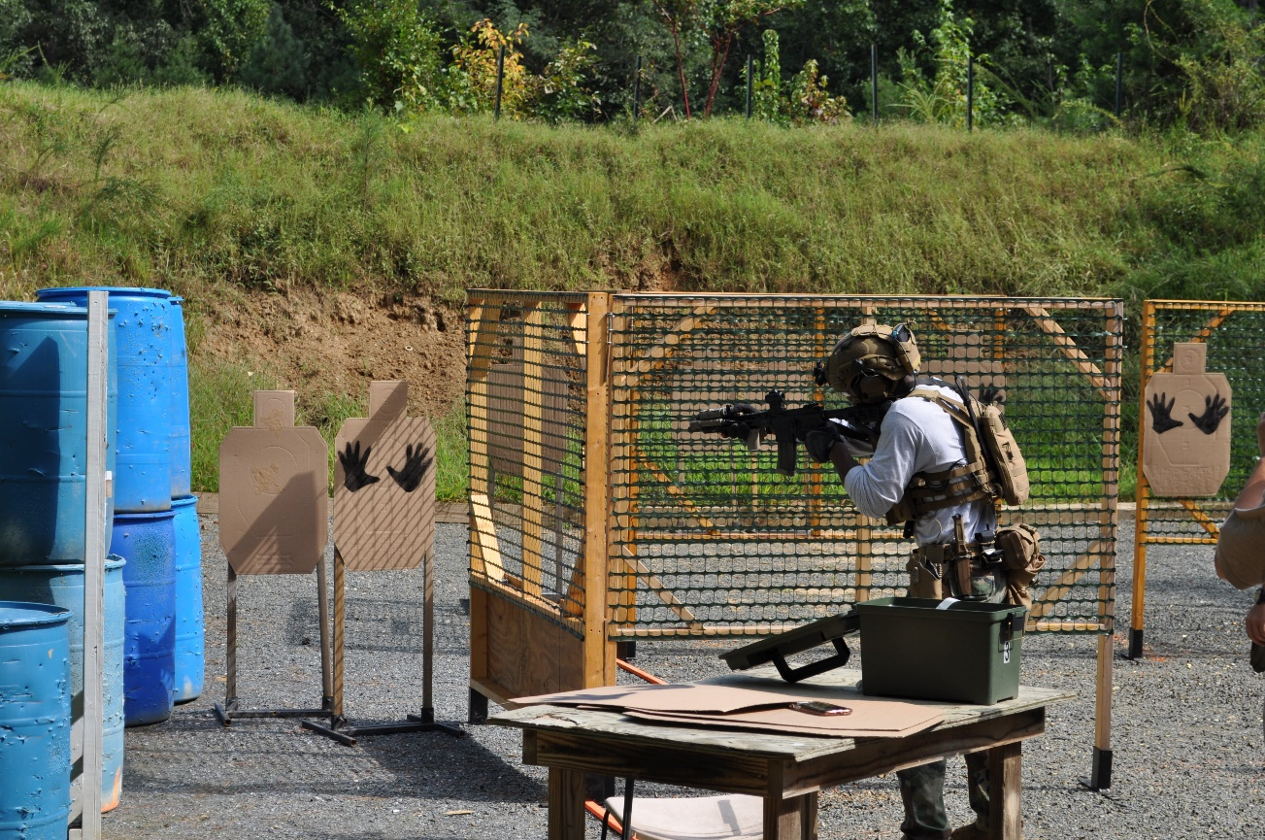

Gathered around for the safety brief

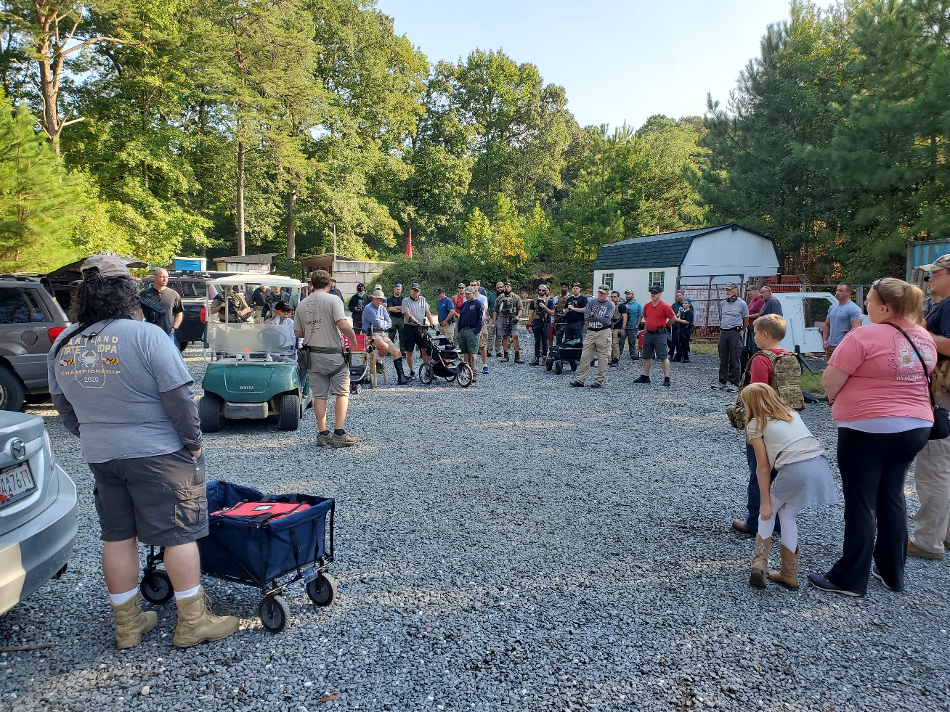

Everyone helping out resetting the stage, setting the example for the rest

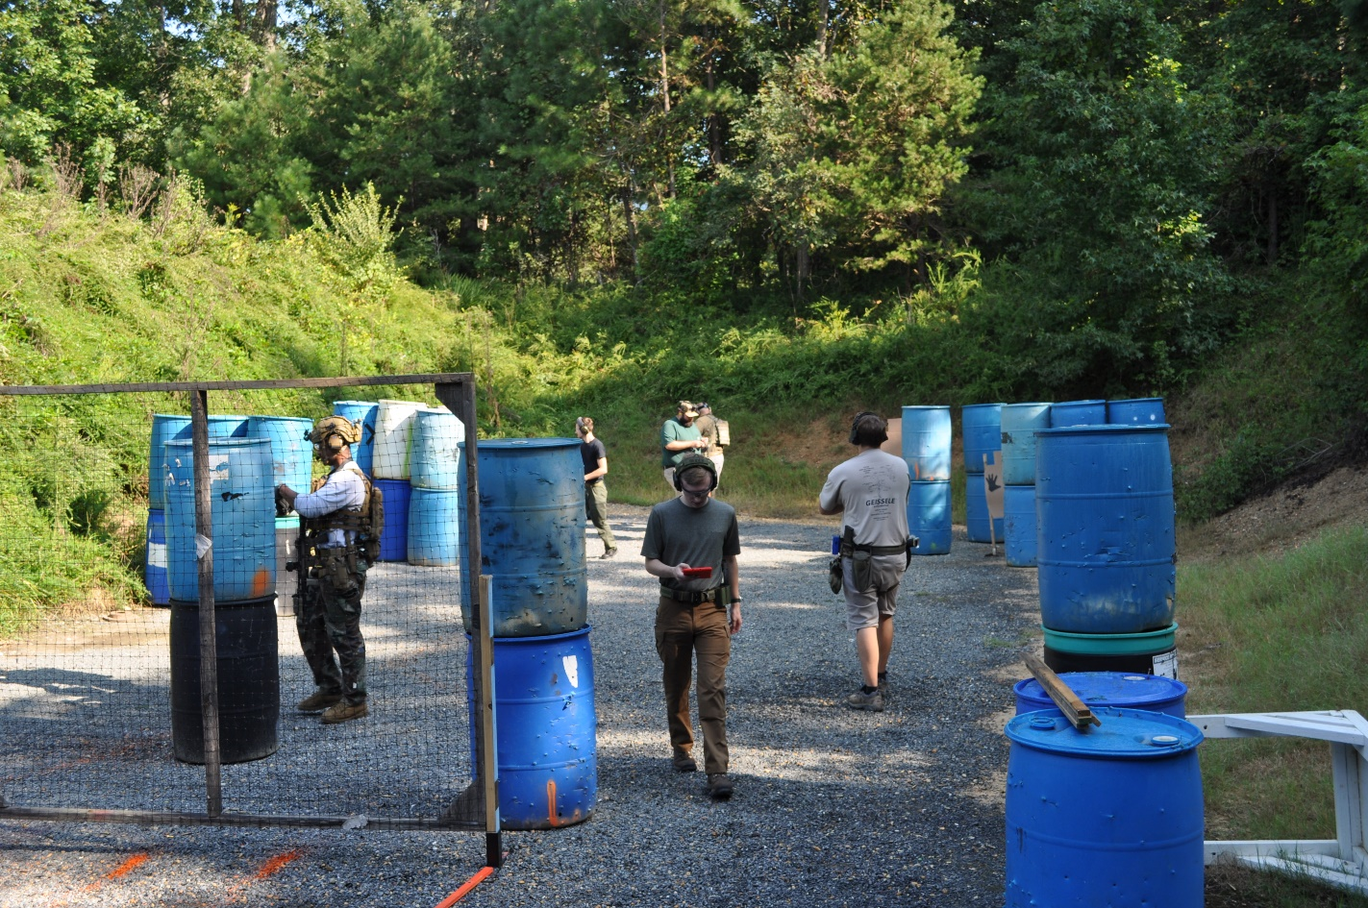

Don’t lose your balance!

