Sanner’s Carbine Classic March Match Report
3/30/2024
Saturday was as good of a shooting day as we could ask for, which was perfect because we had a full house show up for the latest installment of the Sanner’s Carbine Classic.

The day’s match featured five challenging stages with shoulder switching, tight angles, moving targets, and even shooting out of the back of a vehicle. The accuracy challenges presented here seemed to catch some of our top shooters off-guard as a few of them caught some penalties and no one shot a clean match.

We’d like to congratulate Dan Hernandez for taking 1st place overall, in addition to 1st in Dot division. Mark Swierczek was right behind him to clinch 2nd place. We’d also like to give a shoutout to all 14 competitors in Prepper division, which is a record number for the match series. Take a look at the rest of the category and divisions winners below:

High Categories
High Junior: n/a
High Senior: Gary Turner
High Lady: Andrea Swierczek
High Active Duty/LE: Joseph Livi

Divisional Winners
Dot: Dan Hernandez
Ironman: Jeremy Hanson
PCC: David Metcalfe
Prepper: Anibal Delgado
Scope: Andrea Swierczek

Complete results: https://practiscore.com/results/new/238284

Below is a collection of photos from the match as well as two videos from our competitors. The next match will be on Saturday June 15th, see you there!

-Anibal Delgado, Jeremy Hanson, and Jake Swierczek
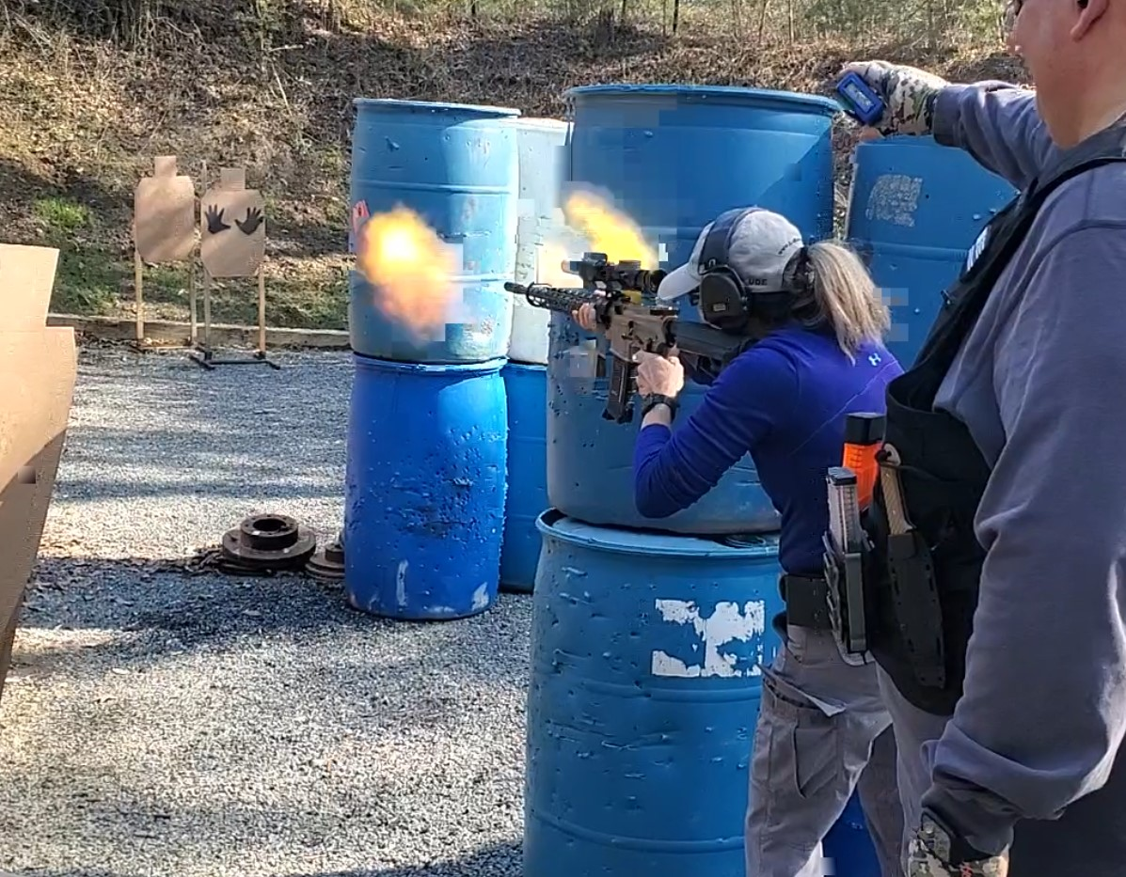
If you aren’t using a suppressor, you may as well let everyone know
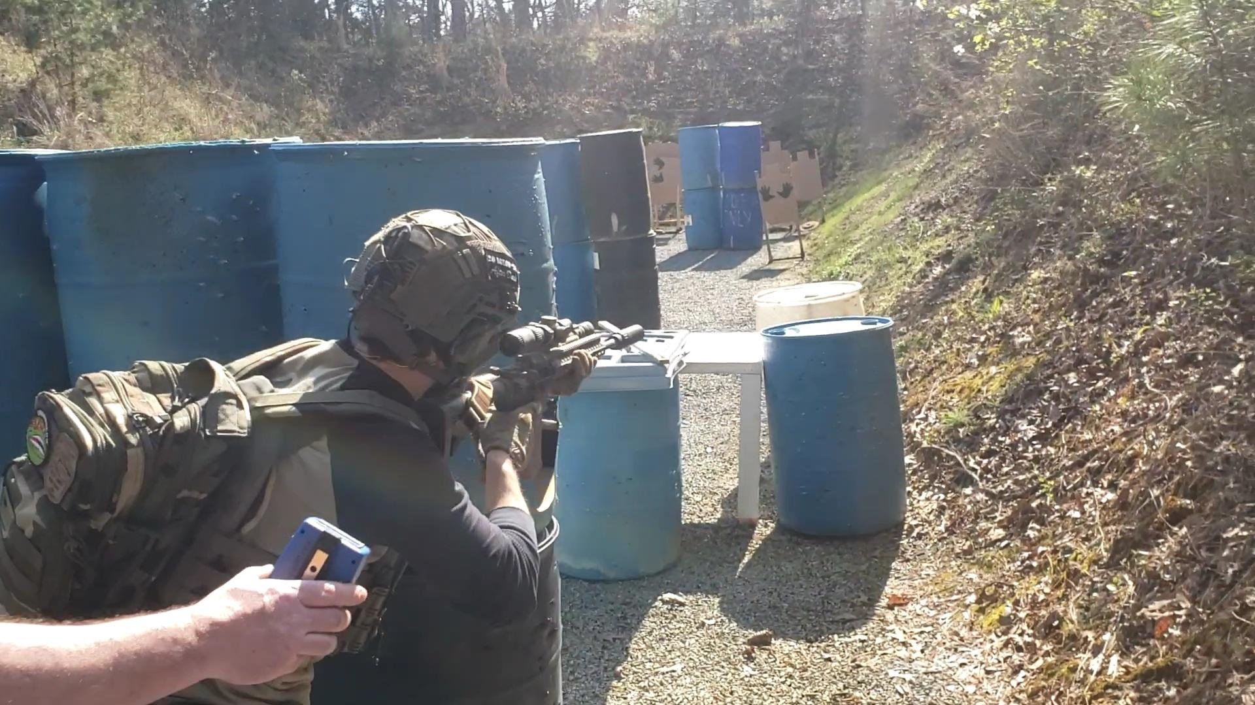
Preppers have a nice counterweight when they really need to lean

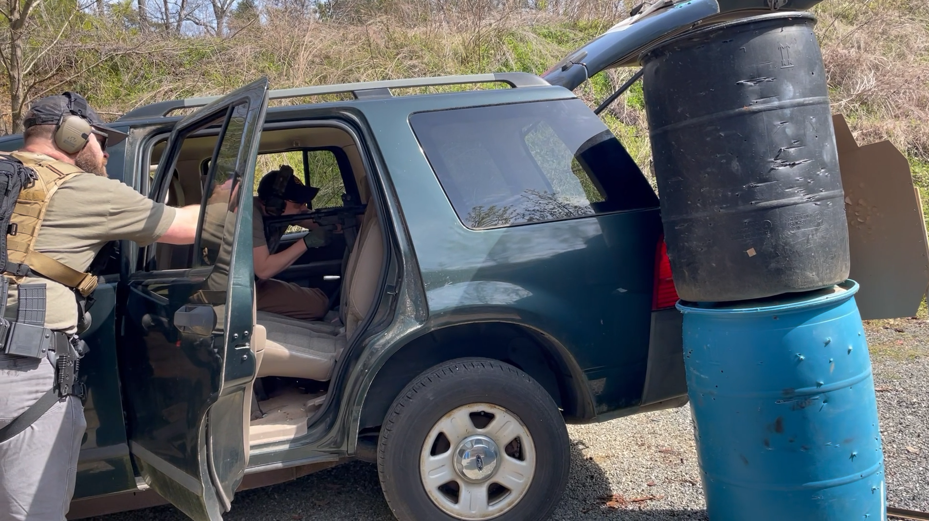
Driving the mean streets of SLSC

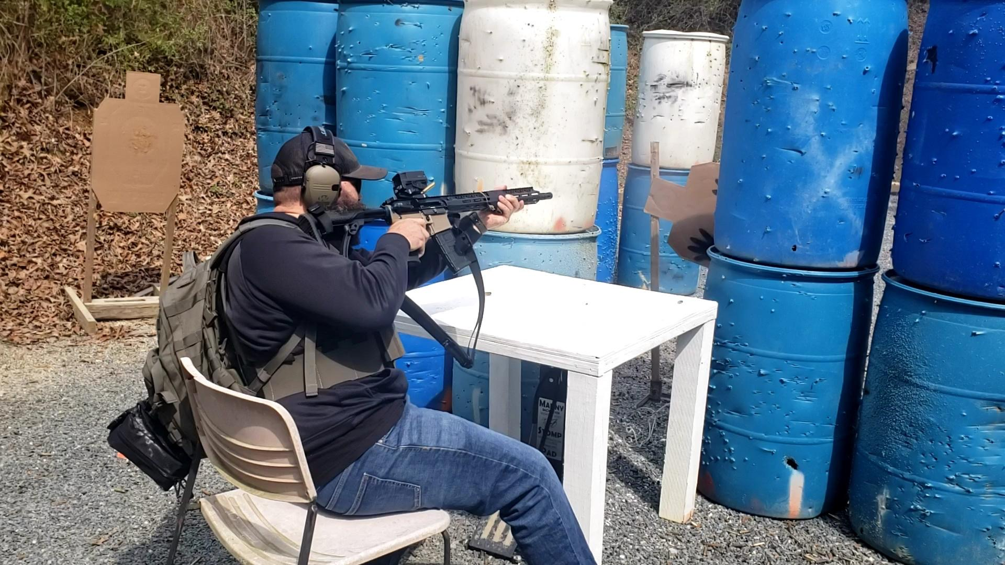
We even make relaxing a challenge

Video montages:
https://www.youtube.com/watch?v=0r0-cAzYKR4

https://www.youtube.com/watch?v=ncQHUj_F3PI

